NIHSS MADE EASY BY HPUPM (26/7/2022)
DISEDAKAN OLEH : DR SUHYNA
1)In Malaysia
-There was a 4.9% increase in stroke incidence between 2008 and 2011among men but a 3.8%
fall among women
-36.2% were discharged independent while 53.1% had functional dependence
-Substantial increase in stroke incidence among those below 65 years old
-The largest increase of 53.3% in men aged between 35-39 years and 50.4% in women of
similar age group

2)The higher trend of stroke in this age group might be related to
-Increase in the burden of cardiovascular risk factors especially hypertension among young
at aged 18-39 years
-The prevalence of undiagnosed dyslipidemia among these age groups ranged from
40.0 to 48 hypertension (18.1-27.9%) and diabetes mellitus (9.5-12 4%)

ACUTE STROKE IS A MEDICAL EMERGENCY

Neurons Lost:
Per Stroke-1.2 billion
Per Hour-120 million
Per Minute-19 million
Per Second-32 000

SPOT A STROKE-how????
LEARN THE WARNING SIGNS AND BE FAST

BE FAST

B-BALANCE(loss of balance/headache/
dizziness)
E-EYES (blurred vision)

F-FACE (one side of the face is drooping)
A-ARMS (arm of leg weakness)
S-SPEECH (speech difficulty)
T-TIME (time to call ambulance immediately)

Lacunar infarct - are small (<20 mm) infarcts in the distal distribution of deep penetrating vessels result from occlusion of one of the small penetrating end arteries result primarily from in situ microatheroma formation or liponyalinosis.

Watershed infarct - are ischemic lesions which are situated along the border zones between
the territories of two major arteries usually caused by hypoperfusion or decreased blood

CLINICAL FEATURES & CLASSIFICATION

In Malaysia widely used classification are:

OXFORD classification - clinical findings
TOAST classification - Based on aetiology

OXFORD CLASSIFICATIONS:
TERM | CLINICAL FEATURES | VASCULAR BASIS
Total Anterior Circulation Syndrome (TACS) | *Hemiparesis AND  * Higher cortical dysfunction(dysphasia or visuospatial neglect) AND  *Homonymous hemlanopia | Usually proximal middle cerebral artery(MCA) or ISA occlusion
Partial Anterior Circulation Syndrome (PACS) | *Isolated higher corticol dysfunction OR  *Any two of hemiparesis,higher cortical dysfunction,hemianopia | Usually branch MCA occlusion
Posterior Circulation Syndrome (POCS) | *Isolated hemianopia(posterior cerebral artery (PCA)) brainstem or cerebellar syndromes | Occlusion of vertebral, basilar, cerebellar or PCA vessels
Lacunar Syndrome (LACS) | *Pure motor stroke OR  *Pure sensory stroke OR  *Sensorimotor stroke OR  *Ataxic hemiparesis OR  *Clumsy hand-dysarthria | Small penetrating artery occlusion,usually in tenticulostriate branches of MCA, or supply to brainstem or deep white matter

TOAST CLASSIFICATION
TERM | CLINICAL | RADIOLOGICAL FEATURES
Large-artery  Atherosclerosis | Signs of lesion in cortex (aphasia,apraxia,neglect),subcortex,cerebellum or brainstem | -CT/MRI shows lesion >1.5 cm in cortex,subcortex,cerebellum or brainstem compatible with the symptoms  -CT scan negative when performed shortly after onset
Cardio-embolic | Signs of lesion in cortex (aphasia,apraxia,neglect),subcortex,cerebellum or brainstem | -CT/MRI shows lesion >1.5 cm in cortex,subcortex,cerebellum or brainstem compatible with the symptoms  -CT scan negative when performed shortly after onset
Small-vessel  disease | Clinical signs of a lacunar syndrome (pure motor,pure sensory,sensorimotor,atactic hemiparesis or dysarthria-clumsy hand syndrome) | -CT/MRI shows lacunar infarction (lesion <1.5cm) compatible with the symptoms  -CT scan negative when performed shortly after onset

STROKE MIMICS
Non-stroke condition presenting with stroke-like symptoms

1)Seizure/Post-Ictal Todd Paralysis
2)Complicated migraine
3)Functional Neurological or Conversion
Disorders

4)Hypoglycaemia/Hyperglycaemia
SevereHyponatremia/Metabolic.
Encephalopathy
5)Hypertensive Encephalopathy/PRES
6)Peripheral Vertigo: BPPV, Labyrinthitis,
Vestibular Neuronitis
7)Bell's Palsy
8)Other: Guillain Barre, Myasthenia Gravis,
MS, Brain Tumour/Abscess,
Encephalitis,Sepsis,Syncope Sent from my iPhone

NHISS SCORE

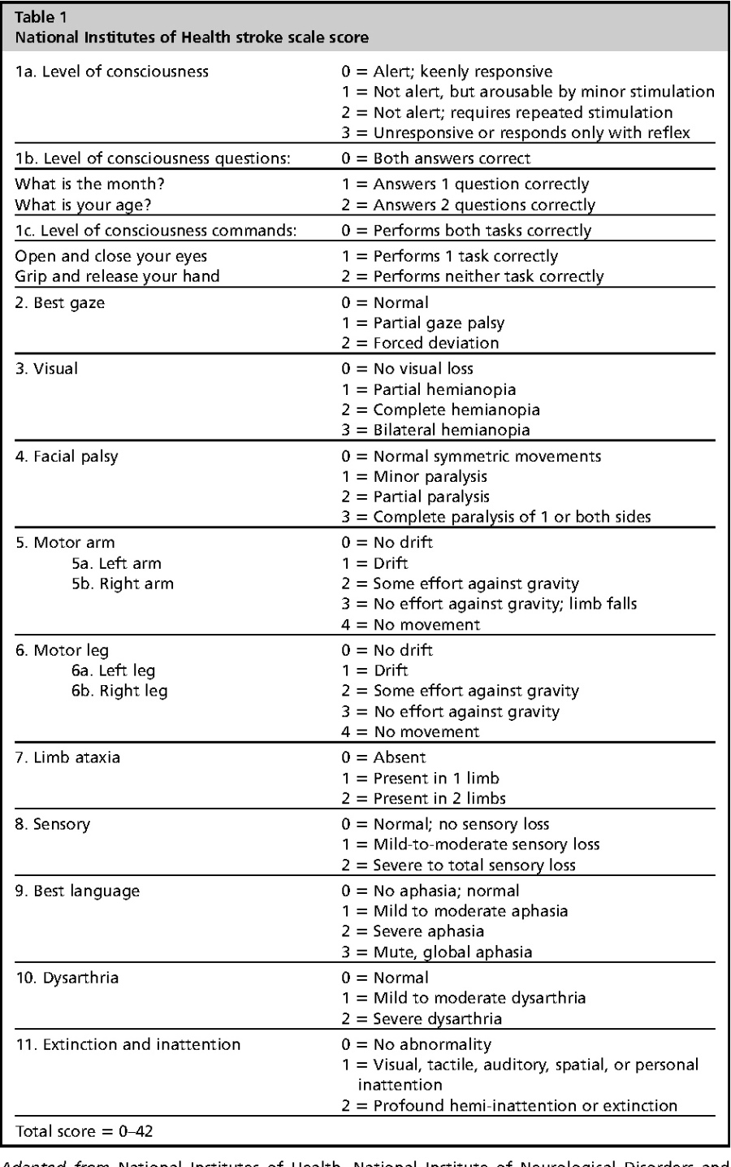

MILD : <4 – NOT INDICATED FOR THROMBOLYSIS
MODERATE : 5-24 – FOR THROMBOLYSIS
SEVERE :Above 25 – NOT FOR THROMBOLYSIS(risk of bleed)

WHEN ELSE FOR THROMBOLYSIS??
- Base on the code:

- Code RED – stroke < 4-6 hrs (hyperacute) -THROMBOLYSIS

- Code YELLOW – stroke 6-24 hrs -THROMBOLYSIS AND

ELIGIBLE FOR THROMBECTOMY ALSO

- Code GREEN – stroke > 24 hrs – Rehabilitation

- ≤ 9hours wake up stroke (midpoint)
- Severe Aphasia
- Within window( <6 hrs)
DWI-ADL-FLAIR (from imaging)

WHEN ELSE ELIGIBLE FOR THROMBECTOMY??

When cortical signs appear – Aphasia
- Hemiparesis
- Neglect
- Homonymous hemianopia

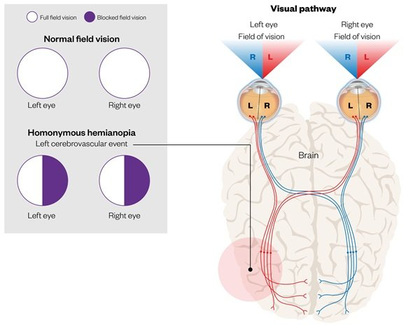

HOW SOON FOR THROMBECTOMY?

- Within 24 hrs (walaupun > 9hrs midpoint stroke)
- Large vessel occlusion
- *MCA/ICA occlusion/yellow code
- Mild to moderate NHISS
*selalunya akan ada cortical signs (aphasia/hemiparesis/homonymous hemianopia/neglect)
*thrombolysis might work as well

Once arrived at rescue, when is the best for thrombolysed stroke patient?
-within window
- DWI-ADL-FLAIR (imaging results)

GOLDEN TIME and state all these in referral letter when you want to refer stroke patient to Res-q

- Time/onset of stroke
- Quality of live before stroke
- NHISS score

*9 hours wake up stroke – GOLDEN hrs
Wake up stroke-midpoint sleep + 9hrs (mesti within 24 hrs)
Lepas 9 jam dari midpoint sleep – dah infarct,tissue not viable anymore, so no need
for thrombolysis or thrombectomy

When to start anti platelet therapy?
- Bleeding risk 6% from thrombolysis-rpt CT scan after 24 hrs thrombolysis-if no bleeding
To start anti platelet

- TIA - double antiply x 1/12.After 1/12, then reduced to single anti platelet only
- NHISS score <6 – double antiply x 1/12.After 1/12, then reduced to single anti platelet only

